Miscellaneous

const ->

const is a keyword in c language

const is a qualifier

yeh qualifier const jis variable ke data type ke sath lag jata hai us me banane wali varaible ki property ko change karata hai ,us ko qualify kar deha hai us ki quality ko inprove kr deta hai

kon si quality bada deta hai ki hum us me koe changes nhi kr sakate

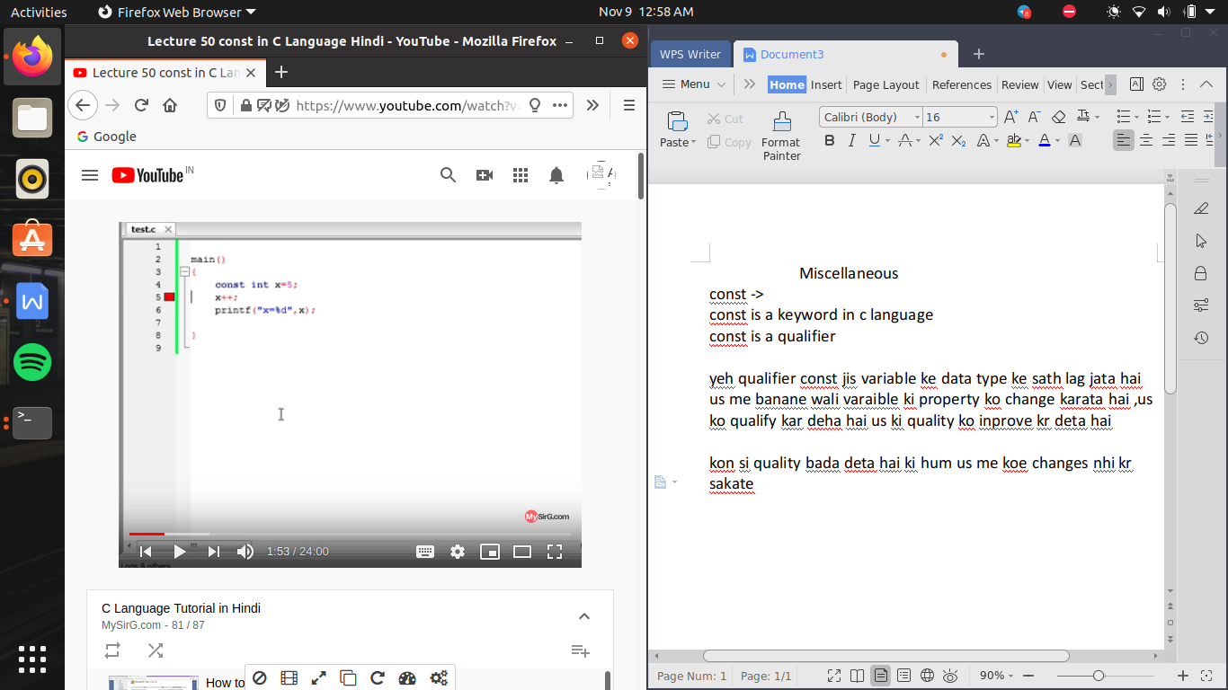

agr change karane ki kosis karege toh yeh error dega , pr pointer ke jariye hum sab kar sakate hai

, pointer ek aisi power full chij hai jis ki madat se hum sare rule tod sakate hai

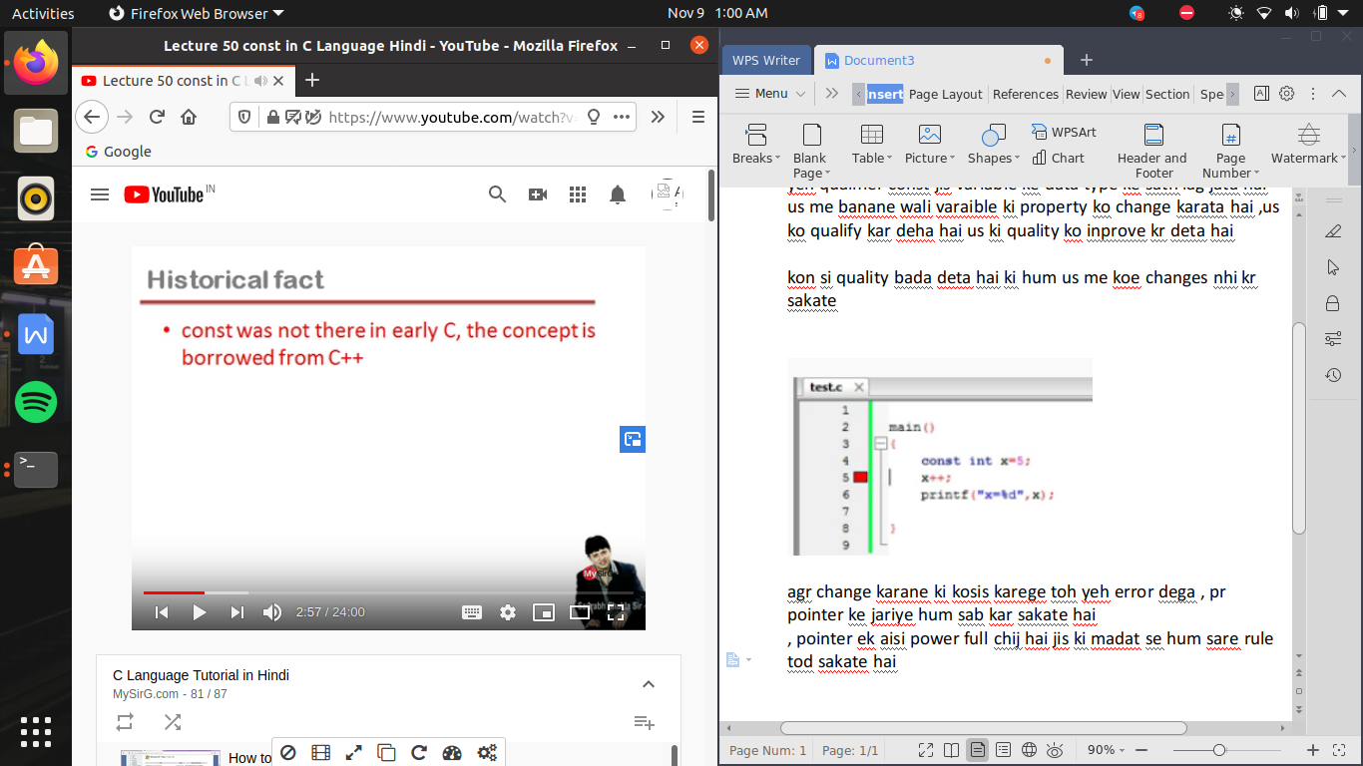

usage of const ->

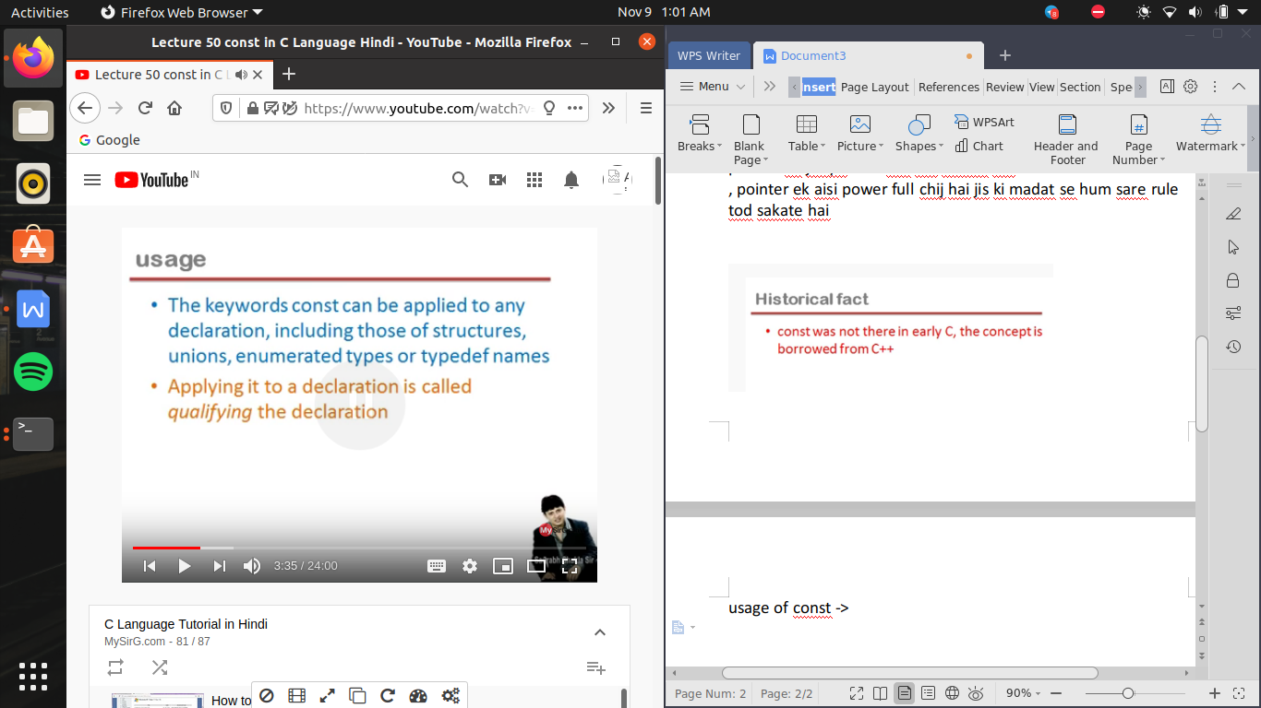

note ->

conts variable ko banate time hi initialize karana chahiye kyu ki , agar hum use banate hai toh us me garbage value i.e a unpredictable value jo ki kuch bhi ho sakati hai us ke andar hai or wohi fix ho gayi hai toh hum use bad me change nhi kr payege

#include<stdio.h>

void main()

{

const int x=5;

int \*p;

p=&x;

printf("x=%d \n",x);

++(\*p); //yani \*&p i.e nothing but x but we not writing it direclty x so we can do increase in the value of x with the help of pointer

printf("x=%d \n",x);

}

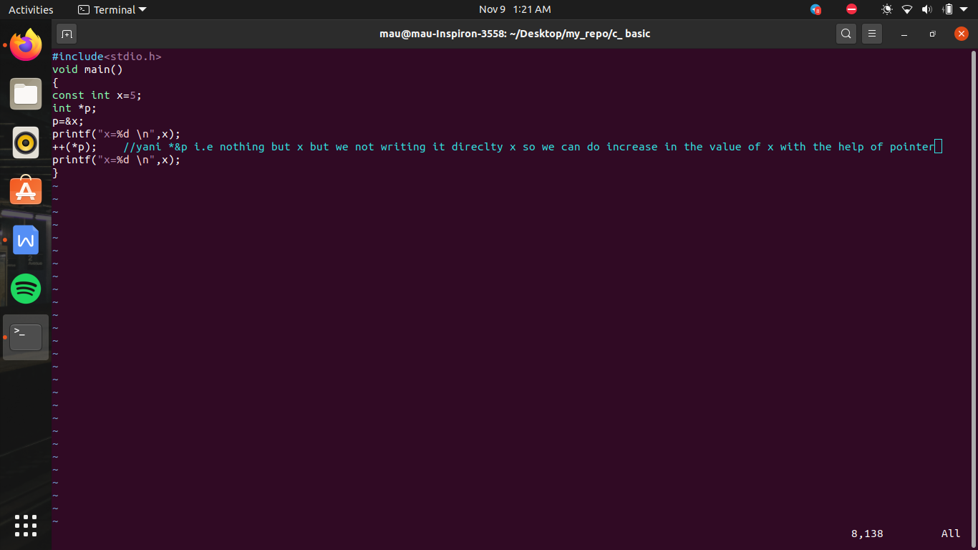

so const se us variable se us ko modify nhi kr sakate

terms

const pointer -> means pointer me rakhi value constant hai use change nhi kr sakate

++p -> error

++(\*p)-> no error

pointer to constant -> means pointer jis variable ko point kar raha hai use change nhi kr sakate toh yaha

++(\*p) ->error

++p -> no error

const pointer to const ->

matlb pointer bhi const hai or pointer jis ko point karega wo bhi const hai

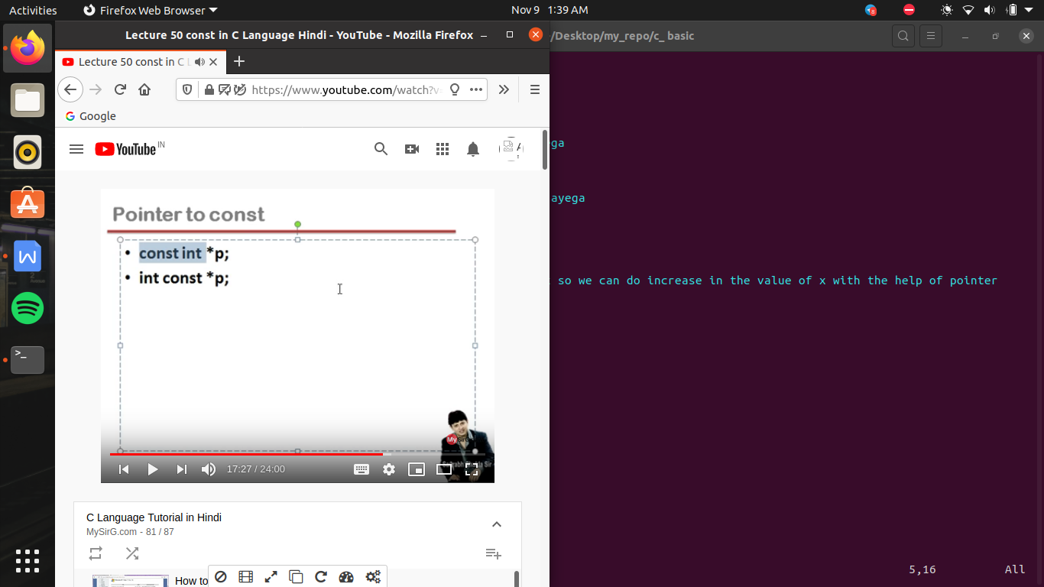

in pointer to const , int and const can interchange but \* and p ke beech me const nhi likhana hai

agar \* and p ke beech me const likha toh wo const pointer kahalayega

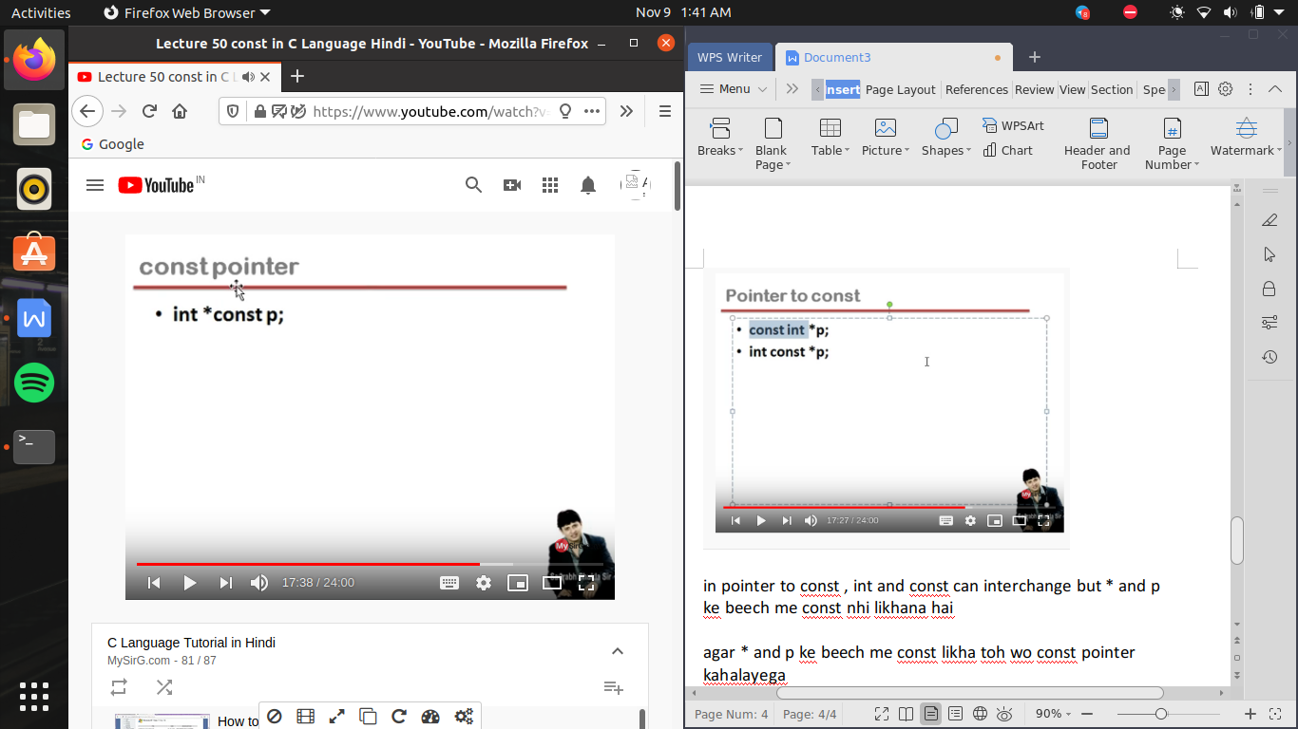

#include<stdio.h>

void main()

{

const int x=5;

int \* const p=&x ;

//i.e const pointer

//yaha pointer is const toh ++p me error ayega balaki ++(\*p) run ho jayega

/\* const int \*p; \*/

// yaha pointer constant nhi hai pointer to const hai yani ++(\*p) error ayega

/\* int \*p; \*/

/\* p=&x; \*/

//in const pointer we can define the value later

printf("x=%d \n",x);

++(\*p); //yani \*&p i.e nothing but x but we not writing it direclty x so we can do increase in the value of x with the help of pointer

printf("x=%d \n",x);

}

